

|  |
| --- |
| ITECH3208 – Project 1  Sprint – 2 Engagement and Contribution Report  Submitted to : Nityansh Rattan |
| |  |  |  | | --- | --- | --- | | Harmanpreet Singh Bedi | 10/14/24 | 30410228 | |

Table of Contents

Project name 3

Software used 3

Contribution towards Project 3

Evidences 4

Evidence 1 4

Evidence 2 10

Evidence 3 11

# Project name

Designing a comprehensive E-Commerce website for XYZ Medical Company

# Software used

* Documentation : Microsoft Word
* Tracking Sprint Progress : Jira Board (Timeline and Backlog)
* Mockups and Prototypes : Figma
* Coding : Visual Studio Code
* Localhost backend server : XAMPP
* Testing : Web Browsers like Google Chrome, Edge and Firefox
* Meetings : Microsoft Teams

# Contribution towards Project

As a developer and project lead of the development team for XYZ Medical Company, I contributed towards the completion of second sprint.

Goals of second sprint :

* Gather feedback on the first sprint from the client.
* Document the new requirements after the feedback.
* Create remaining mock-ups and prototypes.

My role in this sprint :

1. To assign roles to the team members, start the sprint and track progress of every task.
2. Handle all the meetings of this sprint.
3. Create prototypes for all the pages.

# Evidences

## Evidence 1

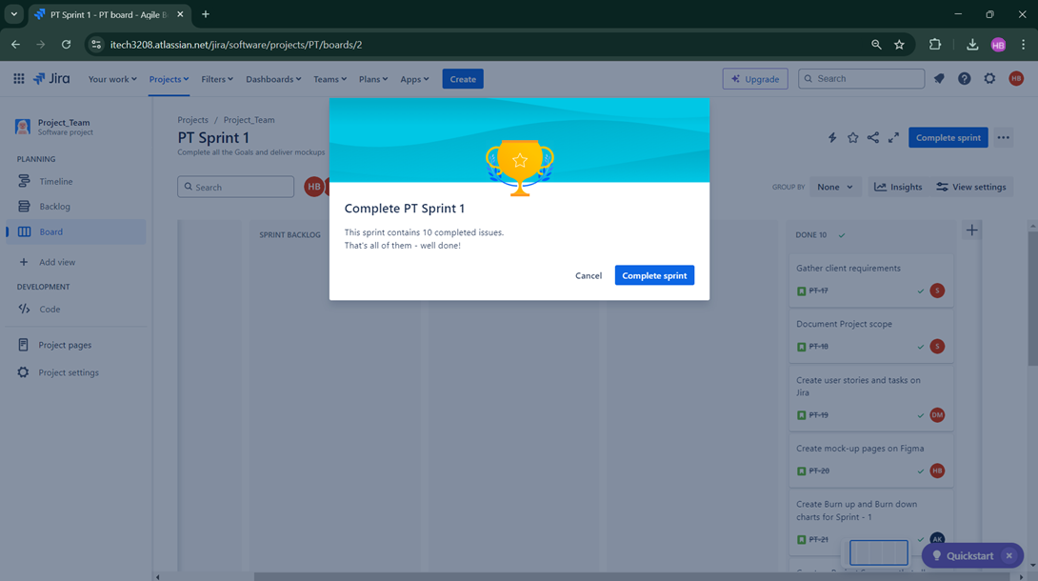Figure 1. Previously completed sprint – 1

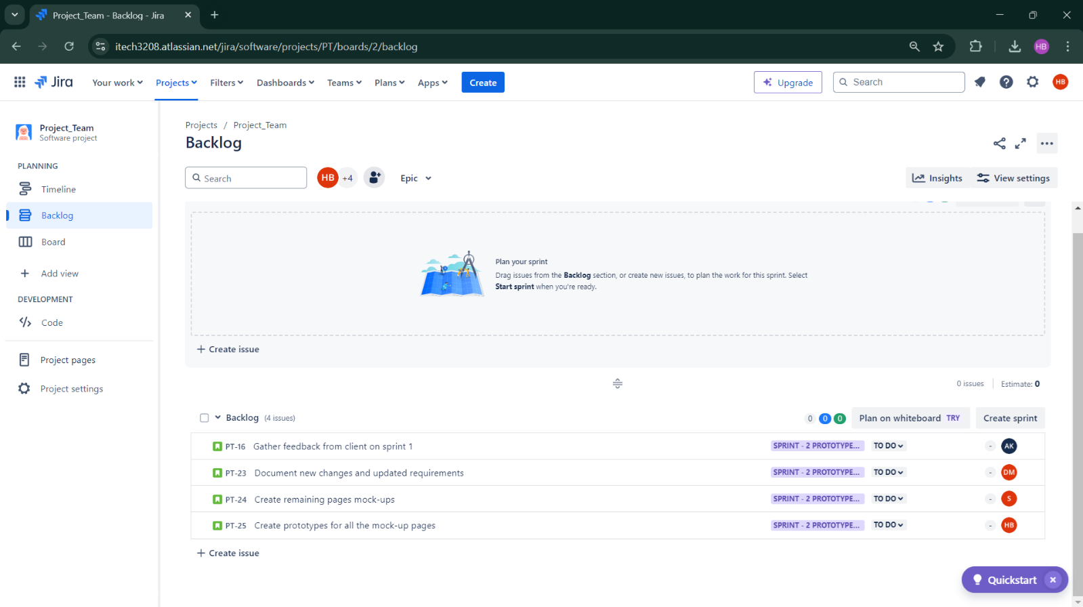Figure 2. Creating Sprint Backlog for sprint – 2

Figure 3. Sprint Backlog moved

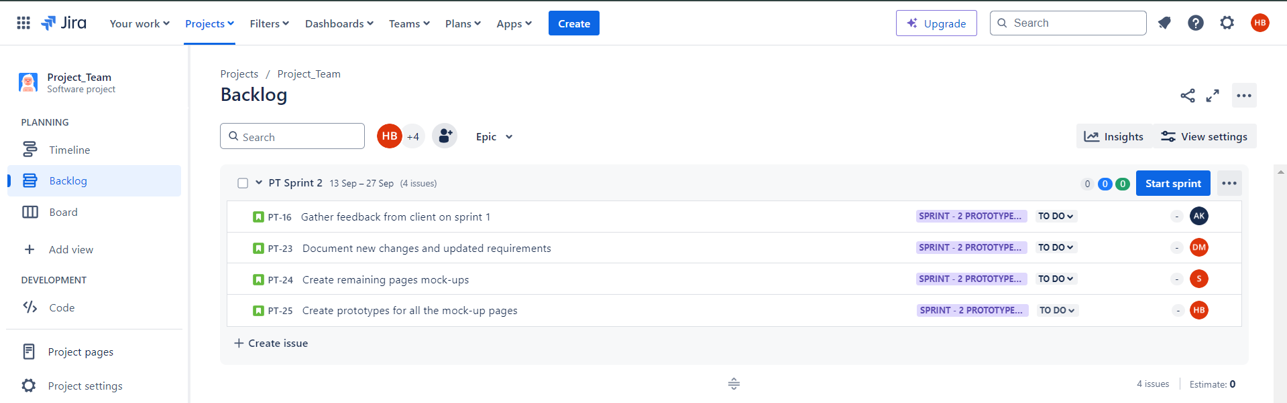

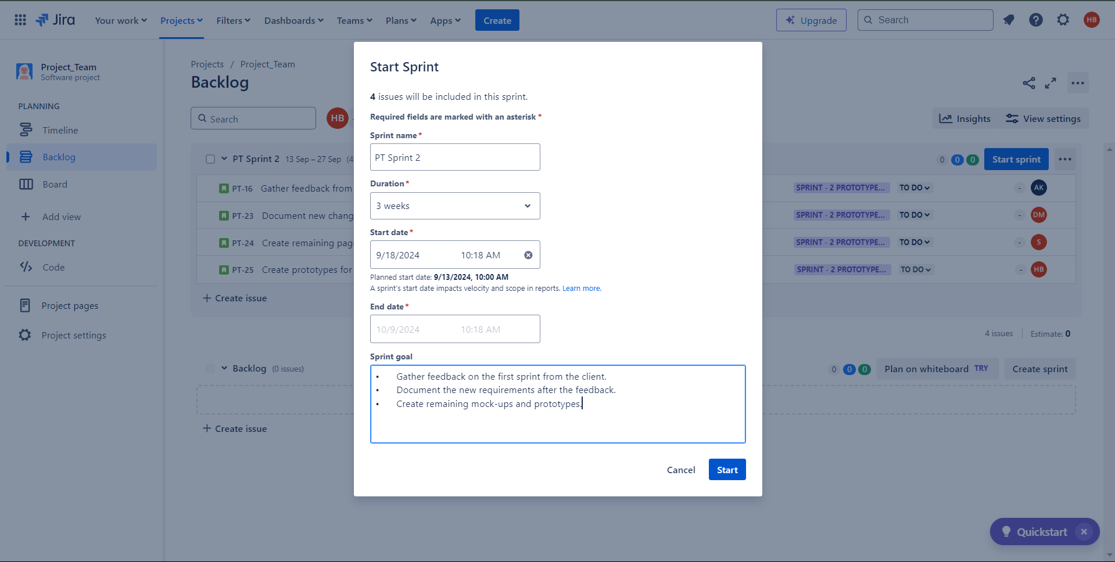

Figure 4. Starting Sprint – 2

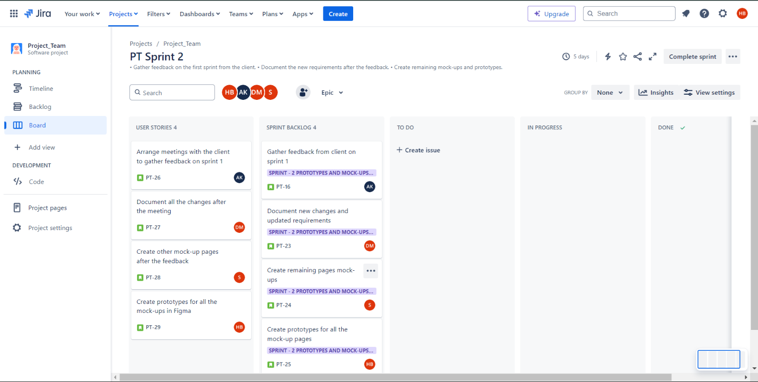

Figure 5. Jira Board for Sprint – 2 with Sprint Backlog and User Stories

Figure 6. To-Do User Stories

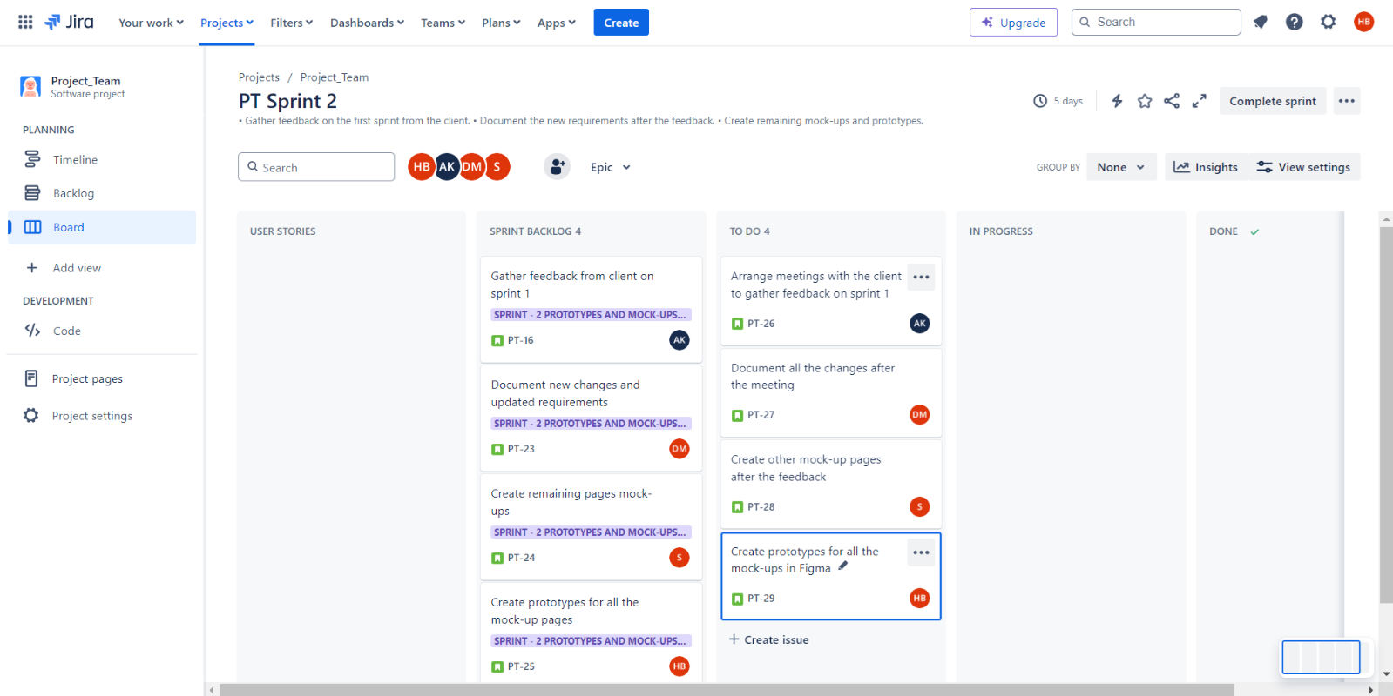

Figure 7. Progress of User Stories

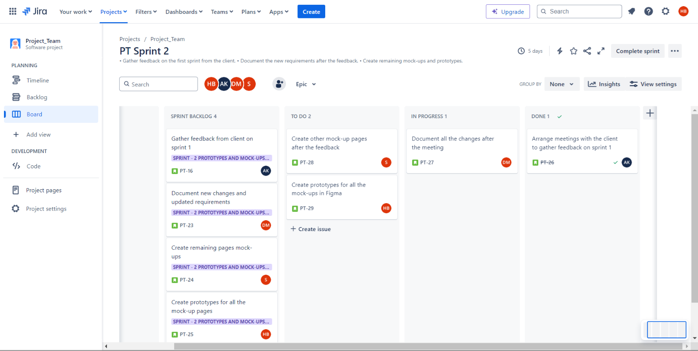

Figure 8. Progress of User Stories

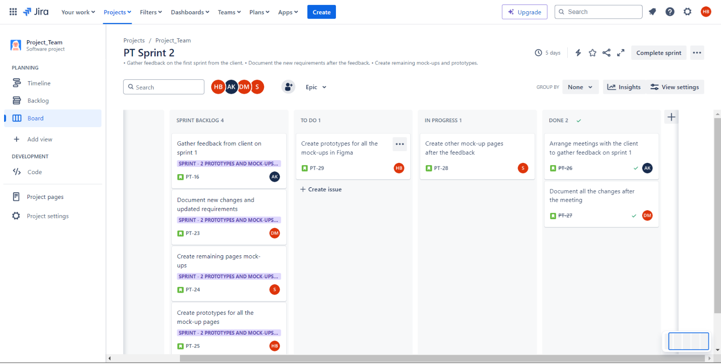

Figure 9. Progress of User Stories

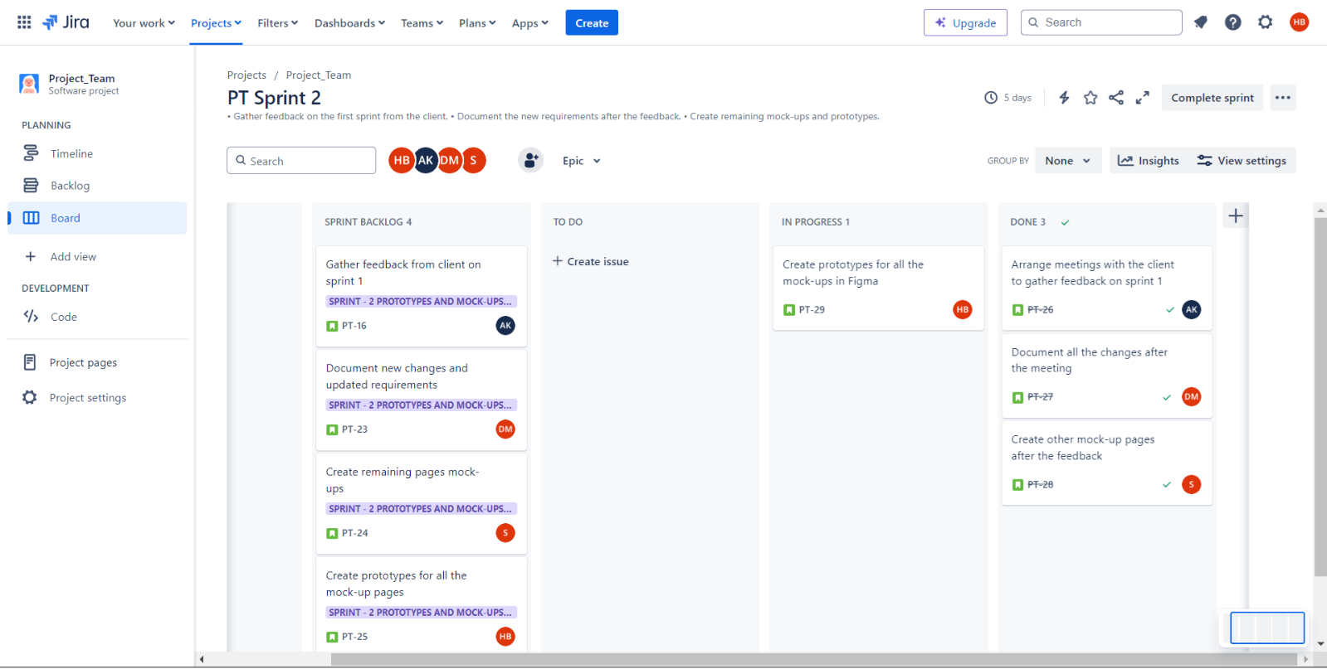

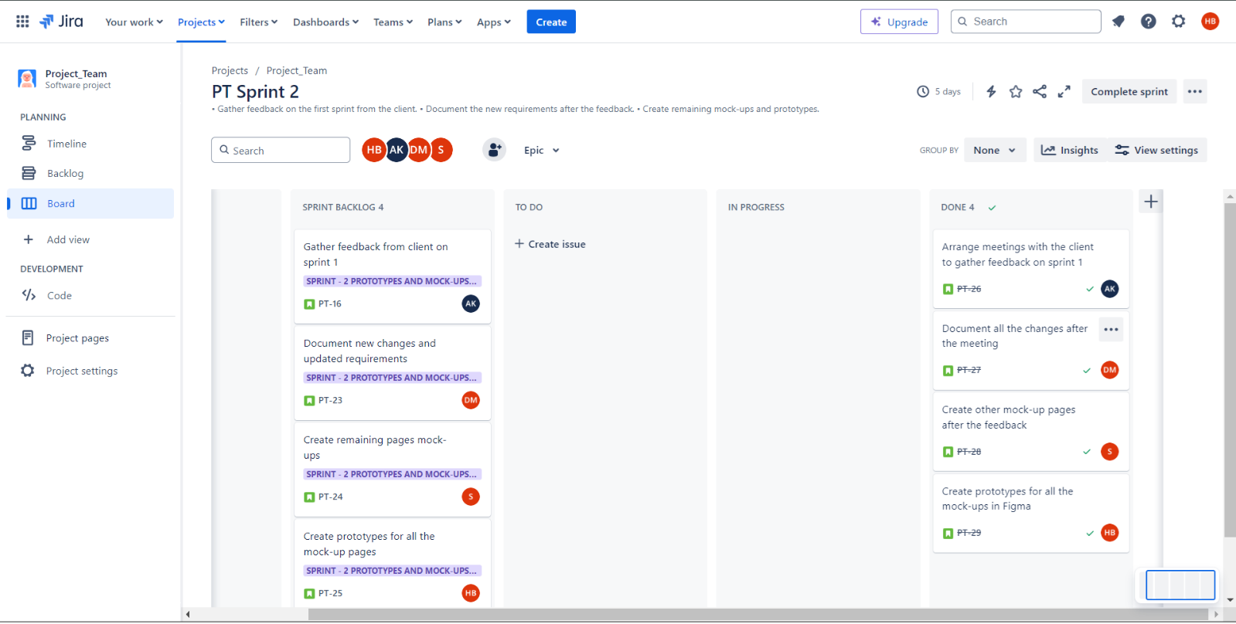

Figure 10. Progress of User Stories

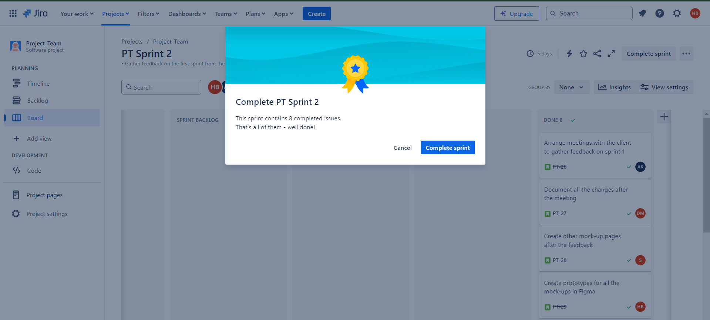Figure 11. Completion of Sprint – 2

Figure 12. Sprint – 2 Timeline

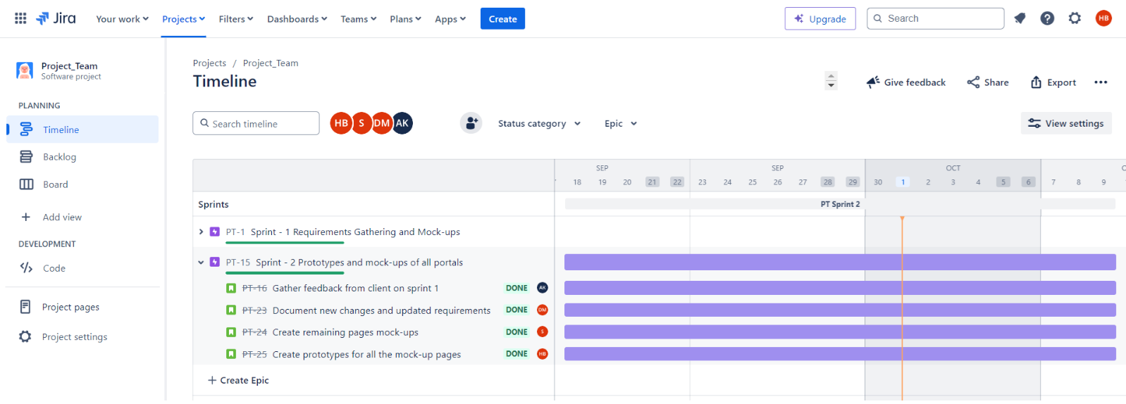

## Evidence 2

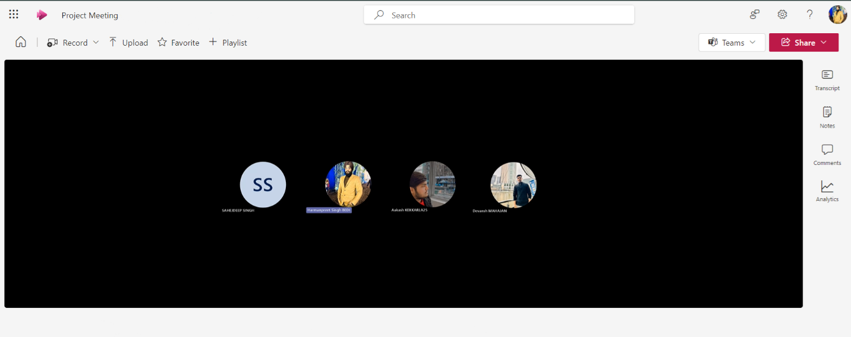I conducted a retrospective meeting at the end of the sprint – 2 to discuss the tasks and challenges faced by all the team members, ensuring all the team members are equally heard and acknowledged.

Fig. 13 Retrospective meeting

|  |  |
| --- | --- |
| **Questions** | **Answers of members** |
| What I did ? | Harmanpreet Singh Bedi : My task in this sprint to evaluate every task’s progress, make remaining mock-up pages and prototypes for all the mock-ups. |
| Devansh Mahajan : I was responsible for documenting any further suggested changes by the client after the completion of the Sprint – 1. |
| Sahejdeep Singh : I made the remaining mock-ups for the other pages. |
| Aakash : I gathered feedback from the client for the Sprint – 1. |
| What are the remaining tasks ? | Harmanpreet Singh Bedi : As of now, no remaining tasks are left. |
| Devansh Mahajan : No remaining tasks. |
| Sahejdeep Singh : No remaining tasks left. All the mock-ups are completed. |
| Aakash : All tasks are done. |
| What challenges I faced in my tasks ? | Harmanpreet Singh Bedi : The major challenge in this sprint was to schedule and match timings. |
| Devansh Mahajan : No such challenge faced. |
| Sahejdeep Singh : No challenge. |
| Aakash : No challenge. |

## Evidence 3

These are the prototypes I developed during the Sprint – 2.

Figure 14. Prototype

Link to Figma window to start prototype : <https://www.figma.com/proto/fsX4U5KlEV9VHV7vsx6yMu/Project_1-Mock-ups?node-id=0-1&t=48IZGnvU5NQPmWtU-1>